For Internal Use Only – Emerson Confidential

 | 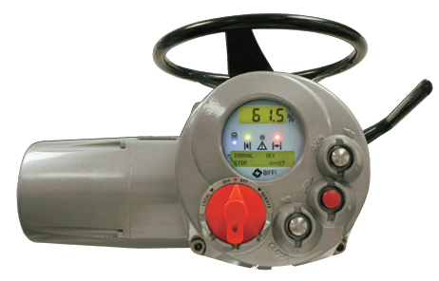
  Product Notice
  BIFFI ICON2000
  FOR YOUR INFORMATION

Dear Customer

Subject : “ICON2000” Series electric actuator replacement

The purpose of this document is to inform you of the obsolescence of the Biffi “ICON2000” series electric actuator, and to present currently - offered replacements for this product.

• Biffi “ICON2000” Series electric actuator is a product made obsolete in 2018 due to the introduction of the new 3000 technology.
Subsequently, support for this product was completely discontinued in 2024.
.
• Biffi “ICON2000” series electric actuator is therefore replaced by the modified and upgraded model ICON3000/V2 series which is completely compatible with the discontinued 2000 model.
• Biffi ICON3000/V2 are modern intelligent, multi-turn electric actuators that improve and expand upon the functionality of the obsolete Biffi “ICON2000” Series.

• Biffi ICON3000/V2 comparison features table are listed in the following doc downloadable at this link:
https://biffi.it/documents/pa-e-bif-2023-0006-biffi-icon3000-electric-actuator-en-us-10268554.pdf

Obsolescence Schedule:
Complete Actuators
Pricing removed from the price book Oct. 1 2024
Cease quotation by *All quotations will be valid till June 18 2024
Deadline for last-time-buy June 18 2024

Spare Parts
Spare Parts availability See table Nr 1
Following table shows the categorization of spare parts and compatibility with the new generation 3000_V2 model.

Actuator Product | Spare Parts | ICON3000_V2
ICON2000
Housing/Covers | Phase Out | N.C.
Logic Board | End of Life 2027 | N.C.
Fieldbus cards | End of Life 2027 | N.C.
Terminal Board | On going | N.C.
Encoder | On going | N.C.
Electric Motors |  | C.
Manual HW |  | C.
Power cards |  | C.
Aux Battery Kit |  | C.
Coupling Base |  | C.
Table Nr 1
C. | Compatible | Same component as 3000V2
N.C. | Not Compatible | Dedicated spares for 2000 models are mandatory

Spare component and assistance service contact:
Biffi Italia
Strada Biffi 165
29017 Fiorenzuola d'Arda (PC) – Italy
Phone: +39 0523 944 411
Biffispares@Emerson.com / BiffiService@Emerson.com
Order Acceptance: We will evaluate the feasibility of fulfilling orders and send an order acceptance notice. The feasibility of delivery depends on the number of components required by our customers. In the case that a final manufacturing process is not feasible due to technical or commercial reasons, we will inform you and attempt to find a solution.
If no solution can be found, we reserve the right to decline the order.
Customer service and engineering support On-going

Literature and Technical Information :
For further information, please contact your Actuation Technologies’ Regional Sales Representative,
For more contact information visit BIFFI website.
Thank you for your continuing commitment to our products and we look forward to addressing your future actuator and process control needs

Please be notified that document are available on the
Emerson| Automation Solutions | Electric Actuator webpage.
Sincerely,

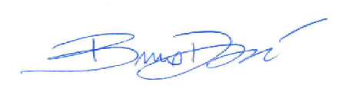
Davoli Bruno
Product Manager
Phone +39 0523-944-401
Bruno.Davoli@emerson.com

For Your Information emails are used by the Actuation Technologies business unit to share product and literature updates
with employees and sales offices worldwide.

Emerson Automation Solutions Actuation Technologies
19200 Northwest Freeway, Houston, TX 77065
© Copyright Emerson 2022

